Joint CQSE & NCTS Seminar

2025
April 25, Friday

Time: April 25, 14:30 ~ 15:30
Title: Universal method for optimized robustness in self-testing of quantum resources
Speaker: Prof. Shin-Liang Chen (Department of Physics, National Chung Hsing University)
Place: NCTS Physics Lecture Hall, 4F, Chee-Chun Leung Cosmology Hall, NTU
Online Link: https://nationaltaiwanuniversity-zbh.my.webex.com/nationaltaiwanuniversity-zbh.my/j.php?MTID=m2a963d31adcf732fcddcf95022ff7210

Abstract:
We introduce a universal method for conducting robustness analysis in self-testing of various quantum resources. Unlike previous approaches that rely on selecting specific isometries, our method optimizes over all possible isometries, thereby enhancing the robustness bounds. This optimization employs the well-established technique of semidefinite programming relaxations for non-commuting polynomial optimization. Our method can be universally applied to various self-testing schemes, such as self-testing of steerable quantum assemblages, dimension-bounded self-testing of quantum states in the prepare-and-measure scenario, and one-sided device-independent self-testing of entangled quantum states. In all the examples that we consider, our method achieves optimal robustness bounds.
Biography:

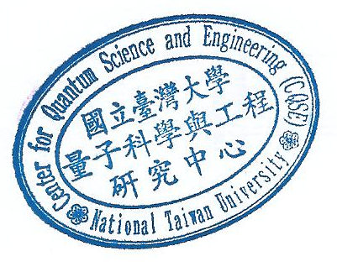
Dr. Shin-Liang Chen is an associate professor at department of physics in National Chung Hsing University, Taichung, Taiwan. Dr. Chen obtained his PhD degree from the department of physics in National Cheng Kung University, Tainan, Taiwan in 2017. After that, he did a one-year postdoc at Max-Planck-Institute of Quantum Optics in Garching, Germany. Then, he moved to the Free University of Berlin as a visiting scholar for around four years. In 2022, Dr. Chen started his appointment at department of physics in National Chung Hsing University. His research focus on quantum information theory, including quantum entanglement theory, quantum nonlocality, and black-box quantum certification.

